SOAR! News

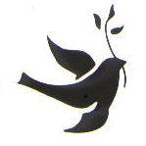
SOAR! News

Support Our Aging Religious, Inc.

Fall 2006 Newsletter

Benedictine Sisters at Prayer, at Work, and in Need

The Sisters of the Order of Saint Benedict at Our Lady of the Rock Monastery in Shaw Island, Washington welcome individuals and families to spend a day or longer in Labora: working on the farm, cutting hay, building fences, feeding animals, or performing any number of needed tasks.
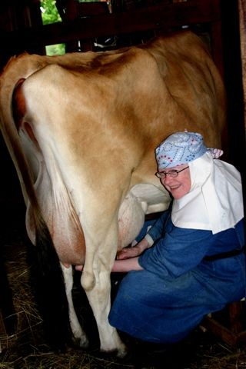
The motto of the Order, Ora et Labora (to pray and to work), is the animating spirit by which the nuns live. Prayer is the first and foundational element of their lives lived in total consecration to Jesus Christ. Stewardship of the land, especially the care of rare breeds of animals, is the community focus.

Guests of all faiths are welcome, including families with children, to seek peaceful refreshment and a closer relationship with God by participating in prayer and any of the following works of their 300 acre farm:
● raising rare breed farm animals
● running one of the few raw milk dairies in Washington State
● maintaining an organic, sustainable, diversified farm
● offering internship programs for students and adults in holistic
farming education
● creating and selling products from the farm and the talents of the
community
● providing a variety of educational experiences for children on the
island including music lessons, 4-H Clubs, birding clubs, and the
stewardship of the land.

The motto of the Order, Ora et Labora (to pray and to work), is the animating spirit by which the nuns live. Prayer is the first and foundational element of their lives lived in total consecration to Jesus Christ. Stewardship of the land, especially the care of rare breeds of animals, is the community focus.

Guests of all faiths are welcome, including families with children, to seek peaceful refreshment and a closer relationship with God by participating in prayer and any of the following works of their 300 acre farm:
● raising rare breed farm animals
● running one of the few raw milk dairies in Washington State
● maintaining an organic, sustainable, diversified farm
● offering internship programs for students and adults in holistic
farming education
● creating and selling products from the farm and the talents of the
community
● providing a variety of educational experiences for children on the
island including music lessons, 4-H Clubs, birding clubs, and the
stewardship of the land.

For the first time in their history, the Benedictine Sisters, with the help of a board of advisors and the local community, are looking outside of the monastery walls to friends, family, and neighbors for financial assistance. For 30 fruitful years the nuns have run the 300 acre farm to support themselves and to serve their neighbors and guests. Now the monastery and farm are showing signs of wear.

The most urgent need of the sisters is for a new monastery roof. When it rains, especially during the wet winters of the Pacific Northwest, water flows directly through the roof into the attic, pools up in the electrical outlets, streams down walls, and drains directly on to the floors. Towels line many window sills and pots strategically placed catch the dripping water.

The prioress, Mother Therese Critchley, says: “As an independent community we rely upon ourselves and the generosity of our friends and guests to maintain the monastery and continue its traditions. We appreciate your prayers and any financial donation you are able to make.” She assures SOAR! of the sisters’ prayers for all our donors.

The sisters’ grant application, along with many other worthwhile requests, will be reviewed at the board of directors meeting in February 2007.

The Beginnings of SOAR! “A Barn-Raising Affair”

SOAR! News Fall 2006 Page 2

SOAR! News Fall 2006 Page 2

Frank Butler, president of Foundations and Donors Interested in Catholic Activities (FADICA), likened the beginnings of Support Our Aging Religious to a “barn-raising affair.” The metaphor seems apt when speaking of a Catholic community coming together to help the plight of elderly religious.

A group of committed Catholics, who appreciated the religious who taught them, cared for them, or employed them, became aware of a growing financial crisis among women religious. In 1985, 115,386 women religious in the United States were at a median age of 63 and burdened with an unfunded liability of $2.5 billion.

The crisis was linked to years of service with little or no compensation, no retirement plans, an aging population, escalating health care costs, and fewer younger members to support their aging members. Many people were surprised to learn that the Catholic Church did not support its religious sisters who dedicated their lives to serving the Church’s ministries.

A group of committed Catholics, who appreciated the religious who taught them, cared for them, or employed them, became aware of a growing financial crisis among women religious. In 1985, 115,386 women religious in the United States were at a median age of 63 and burdened with an unfunded liability of $2.5 billion.

The crisis was linked to years of service with little or no compensation, no retirement plans, an aging population, escalating health care costs, and fewer younger members to support their aging members. Many people were surprised to learn that the Catholic Church did not support its religious sisters who dedicated their lives to serving the Church’s ministries.

In the spring of 1986, a disparate group of Catholic and non-Catholic lay people came together to plan strategies to help resolve the crisis. They were galvanized by a May 19, 1986 article by John Fialka in the Wall Street Journal that exposed the severity of the religious retirement crisis. Based on research sponsored by FADICA's members, the article resulted in an outpouring of public concern. Writer John Fialka and FADICA's Frank Butler agreed that the potential was there to establish a national network of concerned donors who would help educate the public on the great retirement challenges of religious. The advice and counsel of John Wheeler, a founding chairman of Mothers Against Drunk Driving (MADD) proved invaluable in the initial organizing efforts.

In the summer of 1986 a meeting was called on the campus of Trinity College. It was there that SOAR! was born.

Thanks to initial support from FADICA's members, including the Loyola and Leavey Foundations as well as the Catholic Daughters of the Americas, seed money was provided to open SOAR!'s first office and to hire a director.

Free legal counsel was given by the late K. Peter Schmidt and his associate counsel, Patrick Weschler of the law firm of Arnold and Porter. The new organization was incorporated in the State of Maryland on August 19, 1986. Kathleen Nilles of Patton Boggs and Blow led the search committee for SOAR!'s first director, Rita Hofbauer. Jim Dimond, an editor of National Geographic, headed up SOAR!'s direct mail marketing campaign. Denise Hattler of the Loyola Foundation of Washington, DC, volunteered to chair SOAR!'s board and it was "Denny" who cleverly suggested SOAR!'s name.

The creation of SOAR! had ripple effects throughout the country. Before its establishment, the National Religious Retirement Office (NRRO) was created with FADICA's assistance. A national collection for religious was recommended, but the program was slow in starting because no firm commitment on the collection was given by leaders of the Church until the Journal article and SOAR!'s grassroots efforts stirred the waters.
In barn building, the community gathers to help the family in need. The walls that are built and raised demand collaboration and friendship. Once the barn is raised, all involved rejoice.

Outstanding lay people gathered to respond to the plight of elderly and infirm religious. They pooled their resources and put structures in place that resulted in the rise of the NRRO and SOAR! Both organizations are dedicated to advancing the cause of retired and infirm religious in the United States.

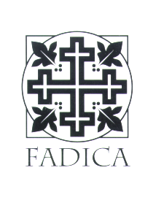
In barn-building, the community gathers to help the family in need. The walls that are built and raised demand collaboration and friendship. Once the barn is raised, all involved rejoice.

Outstanding lay people gathered to respond to the plight of elderly and infirm religious. They pooled their resources and put structures in place that resulted in the rise of the NRRO and SOAR! Both organizations are dedicated to advancing the cause of retired and infirm religious in the United States.

SOAR! NRRO

As in barn-raising, both organizations would not be possible without many people contributing to the building of them. It is time to celebrate in thanksgiving the innovative ideas and the outstanding people who put them to work throughout the country. The achievements fulfill the exhortation of stewardship by Christ in the Gospels.

The work must continue because the need remains. The median age of religious continues to climb and they are confronted with a $7.4 billion shortfall between funds needed and funds available to meet their needs.

SOAR! News Fall 2006 Page 3

SOAR! News Fall 2006 Page 3

SOAR Grants 2005-2006

California
Daughters of Mary and Joseph, Rancho Palos Verdes

Window Replacement
Monastery of the Angels ~ Los Angeles

HVAC Renovations
Servant of Mary, Ministers to the Sick ~ Oxnard,

2005 Hurricane Relief and ADA Bathroom Renovations
Sisters of the Presentation of the Blessed Virgin Mary ~ San Francisco

Medical equipment

Connecticut
Apostoles of Sacred Heart of Jesus ~ Hamden

ADA Bath Renovations

Illinois
School Sisters of Notre Dame ~ Berwyn

Window Replacement, Grab Bars and Cabinets

Kansas
Dominican Sisters ~ Great Bend

Whirlpool Bath with hydraulic lift
Sisters of St. Joseph ~ Concordia

Boiler

Kentucky
Passionist Nuns ~ Whitesville

Whirlpool Bathtub
Louisiana
Dominican Sisters , Congregation of Mary ~ New Orleans
2005 Hurricane Relief
Marianites of the Holy Cross ~ Opelousas
2005 Hurricane Relief
Saint Joseph Abbey & Seminary College ~ St. Benedict
2005 Hurricane Relief
Sisters of the Holy Family ~ Shreveport
2005 Hurricane Relief
Society of Jesus ~ New Orleans
2005 Hurricane Relief

Maryland
Oblate Sisters of St. Francis de Sales ~

Hydro-therapy walk in bath and toilet

Minnesota
Crosier Fathers & Brothers ~ St. Paul

Bed and Bath Renovations
Missouri
Ursulines of the Roman Union ~ Crystal City
2005 Hurricane Relief

Nebraska
Servants of Mary-American Province ~ Omaha

Upgrade Call System

New York
Dominican Sisters ~ Sparkill

ADA Shower/Bath Units
Sisters of St. Joseph of Carondelet ~ Latham

Medical Equipment
Sisters of St. Joseph ~ Buffalo

Video Magnifier
Sisters of St. Joseph ~ Rochester

Medical Therapeutic Mattress and Food Cart
Sisters of Mercy ~ Rochester

Call Bell System

Ohio
Ursuline Sisters ~ Cleveland

Infirmary Renovations
Sisters of Notre Dame ~ Toledo

16 Electric Beds
Sisters of St. Francis, Our Lady of Lourdes ~ Sylvania

Medical Equipment
Sisters of St. Joseph of Medaille ~ Cincinnati
2005 Hurricane Relief

Pennsylvania
Missionary Servants of the Most Blessed Trinity ~ Philadelphia

Ceiling Repair, Electrical and Sound System
Sisters of the Holy Family of Nazareth ~ Philadelphia

Fire Alarm System
Sisters of St. Francis of Millvale ~ Pittsburgh

Window Replacement
Sisters of St. Joseph of NW Pennsylvania ~ Erie

Medical Equipment

Texas
Dominican Sisters ~ Houston

Medical Equipment

Virginia
Our Lady of the Angels Monastery ~ Crozet

Elevator

West Virginia
Sisters of St. Joseph ~ Wheeling

Tub and Chair Lift

Wisconsin
School Sisters of Notre Dame ~ Elm Grove

Code Alert System
Sinsinawa Dominicans ~ Sinsinawa

Flooring, Call and pager system

SOAR! News Fall 2006 Page 4

SOAR! News Fall 2006 Page 4

Mays Mission and SOAR! A Long Friendship

Mays Mission for the Handicapped wishes to express our congratulations to our dear friends at SOAR!
for their twenty years of faithful service and a job well done. Employees of Mays Mission
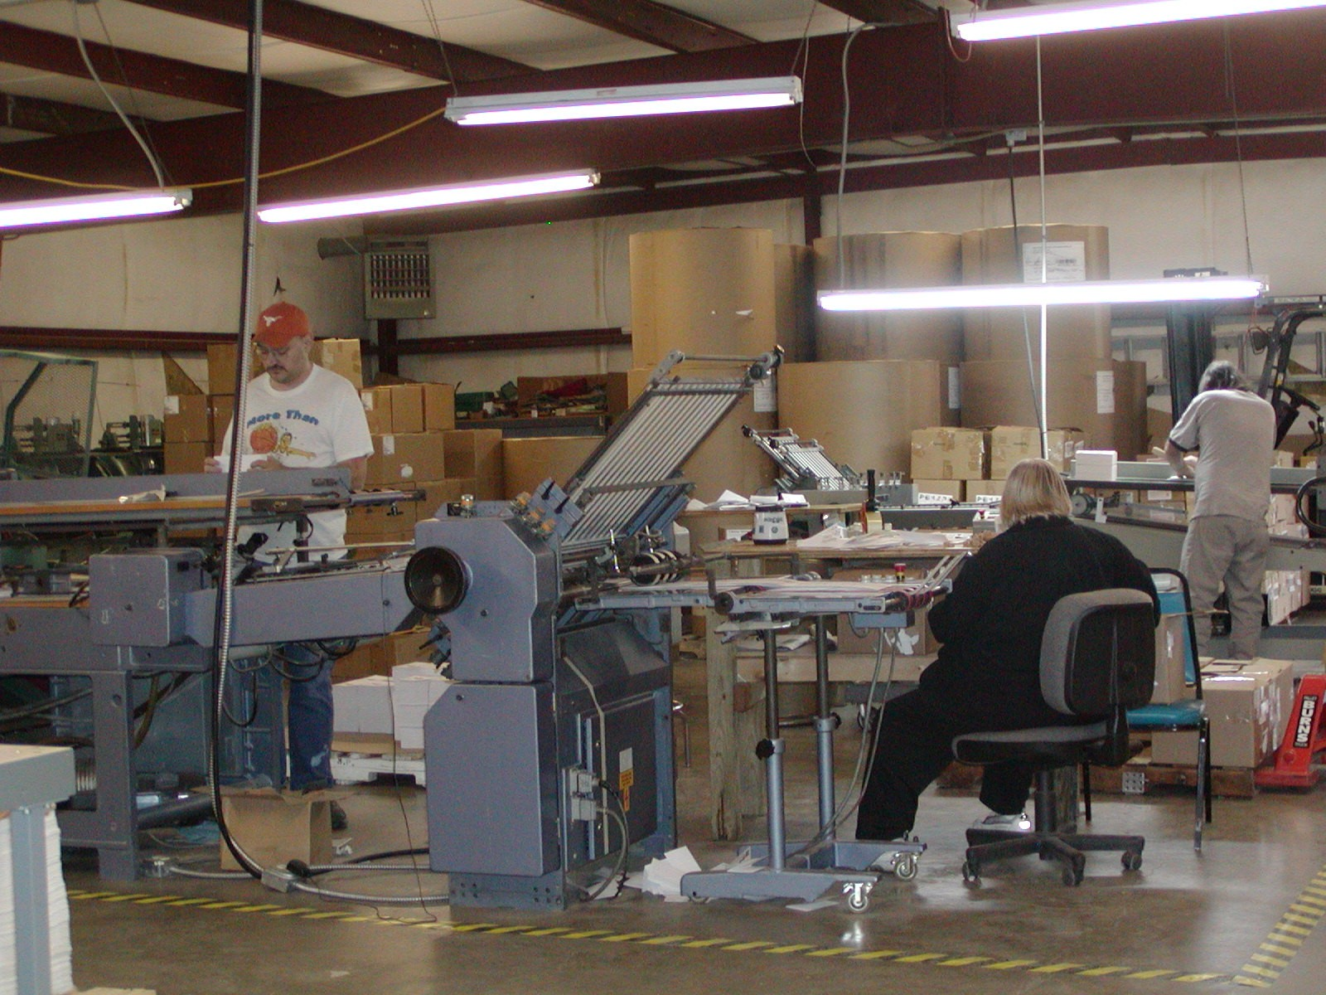
Mays Mission for the Handicapped is a printing and mailing operation used by SOAR! for over 19 years. The business was founded by Ewing W. Mays, a combat-wounded double amputee veteran of World War II. For the past 30 years, he has ministered to people who are disabled.
By visiting hospitalized disabled veterans around the country, Mays quickly discovered that through his fundraising efforts he could provide jobs for the disabled in all walks of life. Mays Mission for the Handicapped became not only a ministry to the disabled, but a first-class printing facility with full-service lettershop and data processing departments employing people with disabilities.
Sherry M. Niehaus, Editor at Mays Mission, said that “The long-standing partnership with SOAR! has been a blessing to the employees at Mays Mission. Our sincere hope is for this bond to continue for many years to come.”

Mays Mission for the Handicapped is a printing and mailing operation used by SOAR! for over 19 years. The business was founded by Ewing W. Mays, a combat-wounded double amputee veteran of World War II. For the past 30 years, he has ministered to people who are disabled.
By visiting hospitalized disabled veterans around the country, Mays quickly discovered that through his fundraising efforts he could provide jobs for the disabled in all walks of life. Mays Mission for the Handicapped became not only a ministry to the disabled, but a first-class printing facility with full-service lettershop and data processing departments employing people with disabilities.
Sherry M. Niehaus, Editor at Mays Mission, said that “The long-standing partnership with SOAR! has been a blessing to the employees at Mays Mission. Our sincere hope is for this bond to continue for many years to come.”

We are proud to announce that we have moved to a new office! Our new contact information is:
SOAR!
900 Varnum Street, NE
Washington, DC
Phone 202.529.7627(SOAR) Fax 202.529.7633
Website www.soar-usa.org

We are proud to announce that we have moved to a new office! Our new contact information is:
SOAR!
900 Varnum Street, NE
Washington, DC
Phone 202.529.7627(SOAR) Fax 202.529.7633
Website www.soar-usa.org

SOAR News is published by Support Our Aging Religious, Inc.
Contributors: Sr. Patricia Sullivan, RSM and Deborah Vornbrock

Printed by Mays Mission www.maysmission.org

SOAR News is published by Support Our Aging Religious, Inc.
Contributors: Sr. Patricia Sullivan, RSM and Deborah Vornbrock

Printed by Mays Mission www.maysmission.org

SOAR!
Support Our Aging Religious
900 Varnum Street, NE
Washington, DC 20017

